**Project Plan**

***Room Use Detection System***

*iO Eindhoven*



*S3-CB01-03*

|  |
| --- |
| **Date** **:** **23-09-2024** |
| **Version** **:** **0.03** |
| **Author** **:** **Kaloyan Rakov, Elena Kalcheva, Dan Zavalidrov, Robert Figaroa & Luuk Steusfij** |
| **State** **:** **In progress** |

#### Version history

|  |  |  |  |  |
| --- | --- | --- | --- | --- |
| **Version** | **Date** | **Author(s)** | **Changes** | **State** |
| 0.01 | 23-09-2024 | Kaloyan Rakov, Pierre Reumkens & Luuk Steusfij | Structure created | Original |
| 0.02 | 24-09-2024 | Pierre Reumkens, Dan Zavalidrov, Robert Figaroa & Luuk Steusfij |  |  |
|  |  |  |  |  |

**Distribution**

|  |  |  |
| --- | --- | --- |
| **Version** | **Date** | **Receivers** |
|  |  |  |
|  |  |  |

Contents

1. Project assignment 3

1.1 Context 4

1.2 Goal of the project 4

1.3 Strategy 4

1.4 Research questions and methodology 4

1.5 End products 5

2. Project organisation 6

2.1 Stakeholders and team members 7

2.2 Communication 7

3. Activities and time plan 8

3.1 Phases of the project 9

4. Testing strategy and configuration management 9

4.1 Testing strategy 10

4.2 Test environment and required resources 10

5. Finances and risk 10

5.1 Project budget 11

5.2 Risk and mitigation 11

6. Git method/way of working 11

6.1 Git flow method 12

# Project assignment

## Context

iO is a Dutch digital marketing company with offices based in 5 countries. They are working with Fontys to solve their room-related issue.

## Goal of the project

iO are experiencing some issues with the scheduling of their meetingrooms, which are available to be reserved and used by their employees. The problems they are facing with these rooms are that sometimes the “status” of a room (whether it’s free or not), doesn’t match the reality. The main goal of this project is to make sure that a room becomes available again, when it is not being used. This project aims to accomplish this goal by means of developing a web app, consisting of a dashboard where, among others things, the people and rooms that don’t meet the requirements are displayed, using an AI model combined with a small computer and a camera. The camera will be placed in the room and use AI to count the number of 'heads' (shapes) currently in the room. For more accuracy, more cameras can be used to cross reference. If the result of the count is not the same on both cameras, it will count again until both cameras count the same number of occupants. For the best result, both cameras can be separated, while still being able to see the entire table.

Furthermore, the system should be expandable to other campuses of iO.

Scope and preconditions

|  |  |
| --- | --- |
| **Inside scope:** | **Outside scope:** |
| 1. Web app | 1. User manual |
| 1. AI-model | 1. Maintenance plan |
| 1. Camera |  |
| 1. Raspberry Pi |  |

## Strategy

For this project, we will be following the SCRUM strategy. We will be meeting with the clients in order to consistently get feedback and complete the final product as close as possible to their expectations. This approach will mainly follow a circular structure; planning, developing and reviewing. Then, the next sprint starts again with the planning taking into account the received feedback. Every sprint takes three weeks. We will have stand-up meetings at least once a week.

## Research questions and methodology

Main research question:

How can we optimize the meeting room availability?

* Is it better to use cameras or thermal sensors to detect if and how many people are in the room?
* Are we going to use microcontrollers or singleboardcomputers and if so which one?
* Do we need to use libraries and if so, which one?
* Do we need to use programming languages other than Java and if so, which one?
* Which capabilities does the Office API have which we can make use of?
* How can we detect people without infringing their privacy?
* How can we develop a room use detection system that is easily scalable to other rooms and/or buildings?
* Where are the devices going to be placed?
* Where is the footage going to be stored if we are going to use cameras?

## End products

Project Breakdown Structure (PBS)

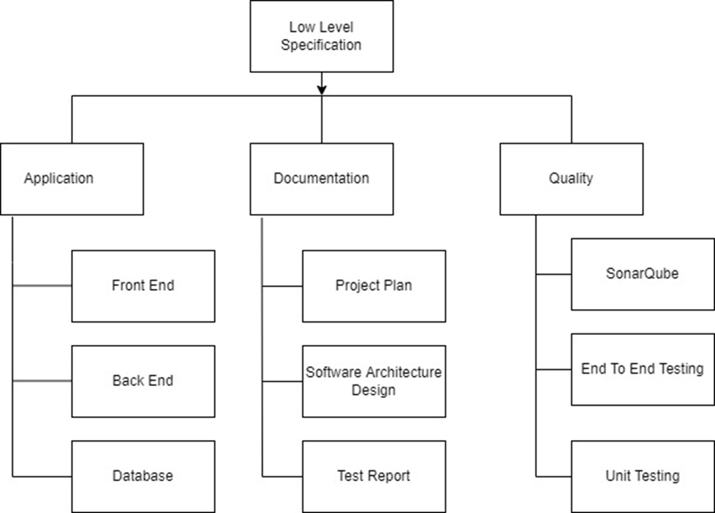

# Project organisation

## Stakeholders and team members

|  |  |  |  |
| --- | --- | --- | --- |
| **Name** | **Abbreviation** | **Role and functions** | **Availability** |
| Dan Zavalidrov | D.Z. | Developer - Student | Mon, Tue, Wed, Thu, Fri ~, Sat, Sun  (d.zavalidrov@student.fontys.nl) |
| Kaloyan Rakov | K.R. | Developer – Student | Mon, Tue, Wed, Thu, Fri ~, Sat, Sun  (507614@student.fontys.nl) |
| Elena Kalcheva | E.K. | Developer – Student | Mon, Tue, Wed, Fri ~  (513834@student.fontys.nl) |
| Robert Figaroa | R.F. | Developer – Student | Mon, Tue, Wed, Thu ~, Fri ~  (514034@student.fontys.nl) |
| Luuk Steusfij | L.S. | Developer – Student | Mon, Tue, Wed, Thu, Fri ~, Sat, Sun  (506052@student.fontys.nl) |
| Timo Veld | T.V. | Product owner – Software engineer | Mon, Tue, Thu, Fri  (timo.veld@iodigital.com) |
| Jop Verhoeven | J.V. | Consultant – Software engineer | (jop.verhoeven@iodigital.com) |
| Merijn Vogel | M.V. | Consultant – Lead software engineer | (merijn.vogel@iodigital.com) |
| Marcus Krielen | M.K. | Consultant – Teacher | Mon, Tue, Thu  (m.krielen@fontys.nl) |

## Communication

The main communication method will be via in-person meetings. The internal stakeholders will also utilize Whatsapp and Discord for communication online. We have weekly standup-meetings where all internal group members attend on Tuesday morning, for the first sprints of the project our Consultant will be present. We aim to meet in-person at the iO office biweekly either with or without the Product Owner (PO). The SCRUM master is the main point of contact between the internal project group and the Product Owner (PO) / Technical Consultant (TC).

|  |  |
| --- | --- |
| **Sprint** | **SCRUM Master** |
| 1 | Robert Figaroa |
| 2 | Dan Zavalidrov |
| 3 | Luuk Steusfij |
| 4 | Kaloyan Rakov |
| 5 | Elena Kalcheva |

# Activities and time plan

## Phases of the project

1. Project Initiation:

Description: In this initial phase, the project is defined, and the team is formed. The goal is to understand the problem to be solved, define project objectives, and identify stakeholders. During this phase, the Product Owner begins to create the initial product backlog.

Key Activities:

● Problem analysis

● Stakeholder identification

● Team formation

● Initial product backlog creation

2. Sprint Cycles (Iterative Development):

Description: The project follows a series of sprint cycles where development work takes place. Each sprint lasts 3 weeks. During these cycles, the project team iteratively implements features and improvements, guided by the product backlog. At the end of each sprint all team members should have a meeting in which they discuss the progress made on the project and also agree on which user stories will be implemented for the next sprint.

Key Activities:

● Sprint planning

● Development and testing

● Sprint review

● Sprint retrospective

# Testing strategy and configuration management

## Testing strategy

Unit testing will be used to verify if functions work correctly, all tests must pass before they get added into production to avoid broken code from being distributed. The only code that will be tested are the API endpoints, classes/methods used by these endpoints or classes/methods that use these endpoints will not be tested.

## Test environment and required resources

We will use a DTAP like environment, before code gets added to production it will first have to pass all tests and be reviewed by members of the team. The CI/CD pipeline will take care of running the tests and finding potential flaws in the code. We’ll use gitlabs cloud environment to run said CI/CD operations. The CI/CD will only run on the main branch and on pull requests to save resources, as mosts tests won’t be passing in development anyways.

# Finances and risk

## Project budget

##### Depends on requirements aligned with initialization and modification of and during the project.

## Risk and mitigation

|  |  |  |
| --- | --- | --- |
| **Risk** | **Prevention activities** | **Mitigation activities** |
| 1. Person dropping out of the group. | Continuous communication through the specified platforms. | In case a member is not going to continue working on the group project, we communicate that with the teachers. |
| 1. People come late for meetings. | Agreeing on a starting time, which satisfies all of us. | Using Microsoft Teams to speak, if the person is unavailable. |
| 1. Technical Challenges. | Communicate with teachers to solve the problem. | Maintain regular communication with professors to seek guidance and solutions when encountering challenges. |
| 4 Changes in project requirements. | Communicate often with the client to know what needs to be done. | Ensure that any changes are aligned with the project's overall goals and priorities. |

# Git method/way of working

## Git flow method

This will be our method for our group project idea. This will highly contribute to our persistence during the development of the system, and consistency of what each of us has to do and finish tickets at the end of each release in each sprint. This will make us to be focused more on result than actual process that what also is a requirement from our product owner.